**Lesson 5 Demo 1**

**Integrate Git with Jenkins**





Steps to be followed:

1. Install Git plugin

**Step 1: Installing Git plugin**

* 1. Open the browser, and go to **Jenkins dashboard** by typing **localhost:8080** in your browser.

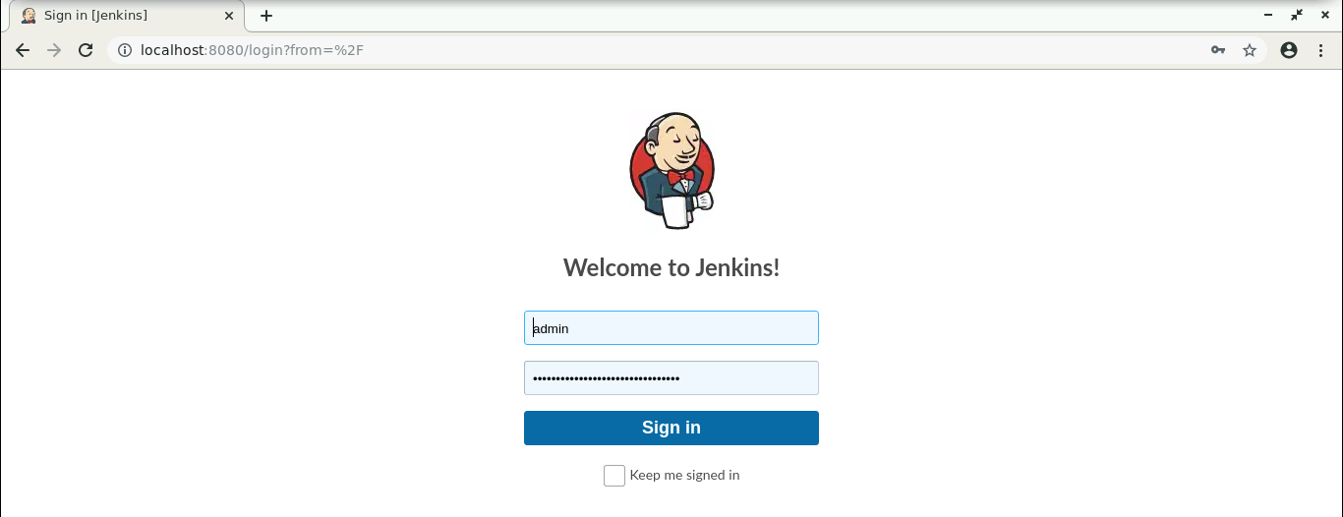

* 1. Provide the credentials, and click on **Sign in**.

1.3 Click on **Manage Jenkins**. From the list of options, choose **Manage Plugins**.

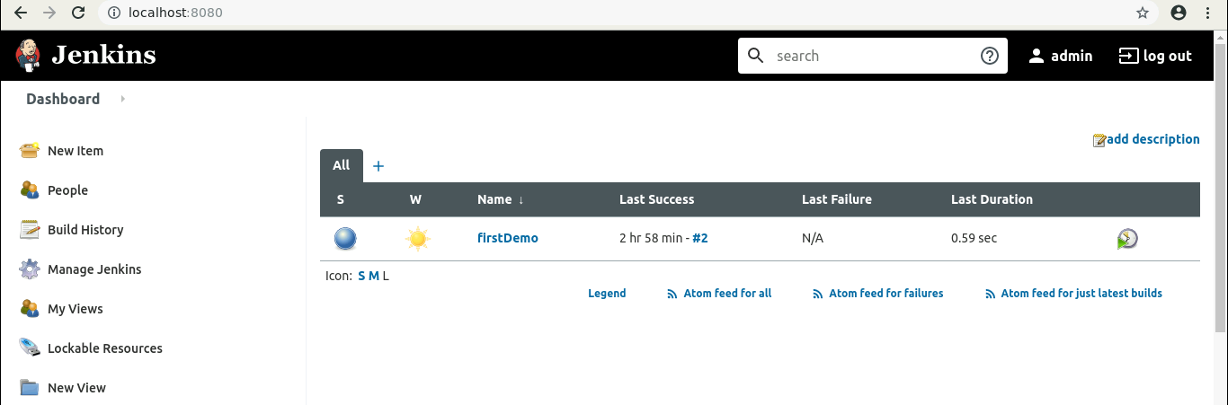

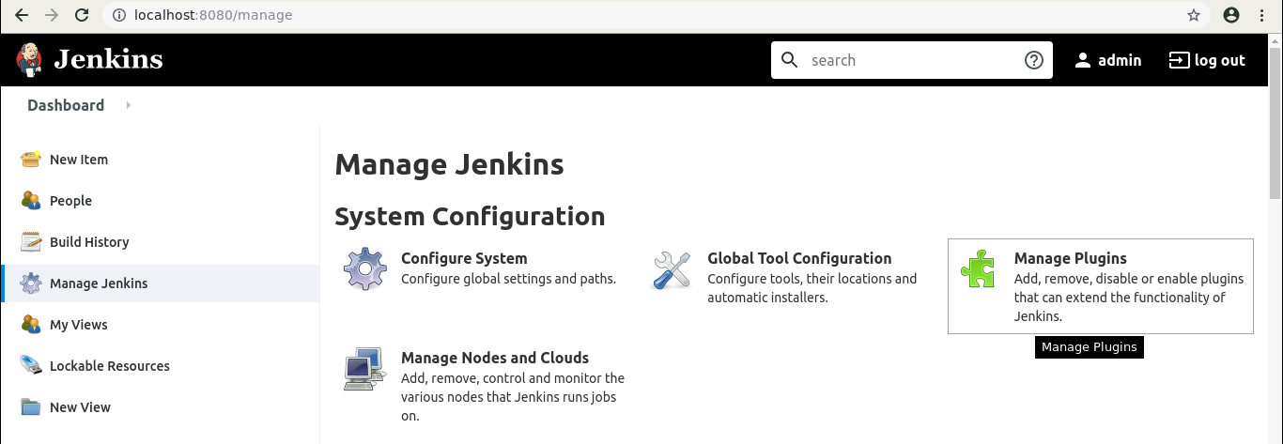

* 1. Under the **Available** tab, select **Git Plugin**.

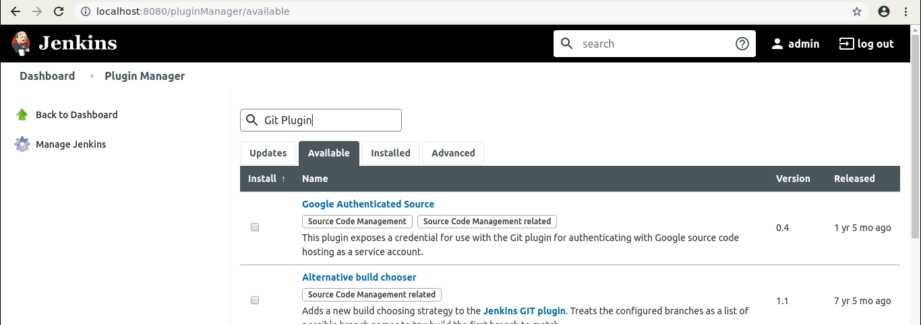

* 1. Click on **Install without restart,** and the plugin will be installed.

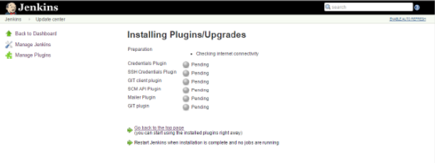

* 1. To verify whether the plugin is installed, go to **Dashboard**, click on **Manage Jenkins**, select **Manage Plugins**, go to **Installed** tab, and search for Git plugin.

